**MS SQL Hands on Exercise**

**Name: Aniroop Gupta**

1) Retrieve All Rows using where

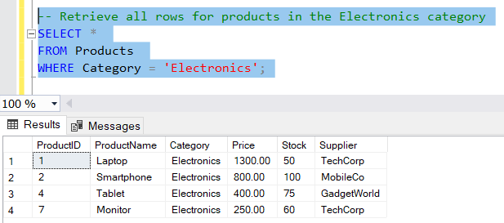

2) Using AND/OR

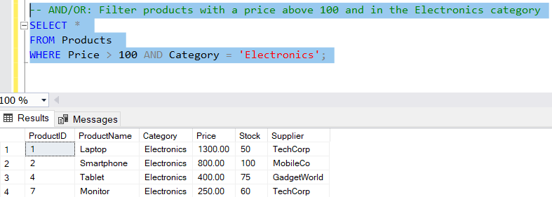

3) Using Group By

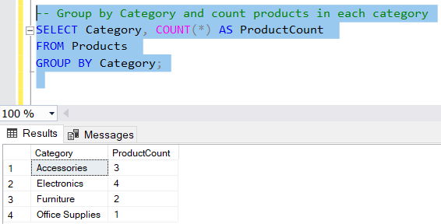

4) Using Order By

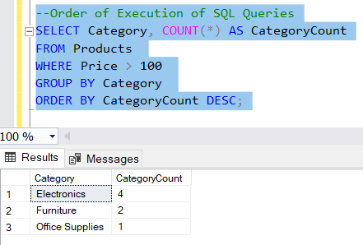  
  
5) Using Aggregation Function

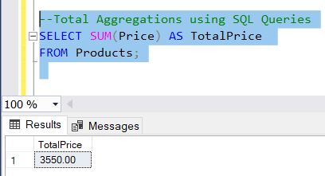  
  
6) Using Mathematical Function

